AGRIBUDDY – Farmer chatbot
Code:
# AgriBuddy - Rule-Based Farmer Chatbot
print("🌾 Welcome to AgriBuddy!")
print("Your simple farming information assistant.")
# Ask the user's name before the main conversation
name = input("What is your name? ")
print()
print("Hello", name + "! 👋")
print("I can help you with:")
print("1. Weather")
print("2. Crops")
print("3. Fertilizer")
print("4. Equipment")
print("5. Market prices")
print("6. Government schemes")
print("Type 'bye' or 'exit' to leave.")
print()
# Keep the conversation running
while True:
# Receive and clean the user's message
user_input = input("You: ").lower().strip()
# Exit condition
if user_input == "bye" or user_input == "exit":
print("AgriBuddy: Goodbye", name + "! 🌾")
print("AgriBuddy: Happy farming!")
break
# Greetings
elif "hello" in user_input or "hi" in user_input:
print("AgriBuddy: Hello", name + "! 🌱")
print("AgriBuddy: How can I help you today?")
# Weather topic
elif "weather" in user_input:
print("AgriBuddy: Weather information is important for farming.")
print("AgriBuddy: Check rainfall and temperature before planning")
print("AgriBuddy: important farming activities.")
# Crop topic
elif "crop" in user_input:
print("AgriBuddy: Crop selection depends on factors such as")
print("AgriBuddy: soil condition, water availability and climate.")
# Fertilizer topic
elif "fertilizer" in user_input:
print("AgriBuddy: Fertilizer decisions should consider")
print("AgriBuddy: the crop and soil nutrient requirements.")
print("AgriBuddy: Avoid applying fertilizer without checking the need.")
# Equipment topic
elif "equipment" in user_input:
print("AgriBuddy: Farming equipment can be rented or shared")
print("AgriBuddy: to reduce the cost of purchasing machinery.")
# Market price topic
elif "market" in user_input or "price" in user_input:
print("AgriBuddy: Market prices can help farmers decide")
print("AgriBuddy: where and when to sell their crops.")
# Government scheme topic
elif "scheme" in user_input or "government" in user_input:
print("AgriBuddy: Government schemes may provide support")
print("AgriBuddy: to eligible farmers.")
print("AgriBuddy: Always check the official scheme information.")
# Help option
elif "help" in user_input:
print("AgriBuddy: You can ask me about:")
print("AgriBuddy: weather, crops, fertilizer, equipment,")
print("AgriBuddy: market prices or government schemes.")
# Unknown message
else:
print("AgriBuddy: Sorry", name + ", I didn't understand that.")
print("AgriBuddy: Try asking about weather, crops, fertilizer,")
print("AgriBuddy: equipment, market prices or government schemes.")
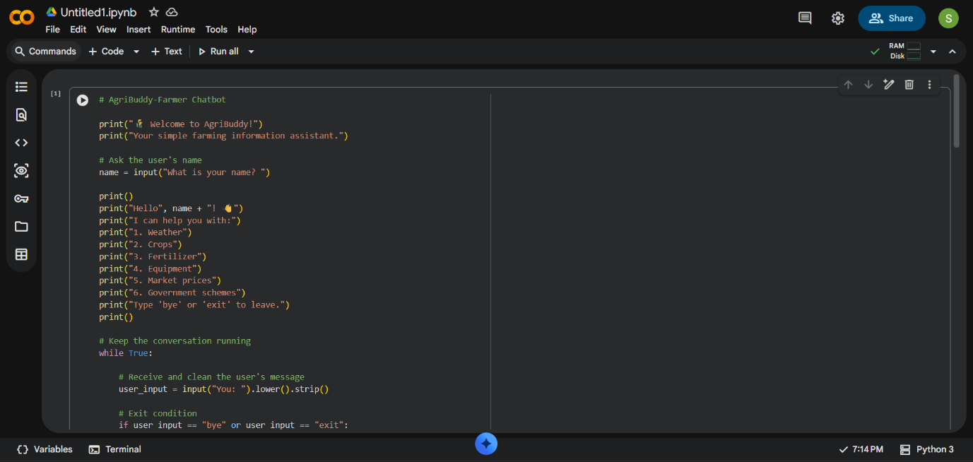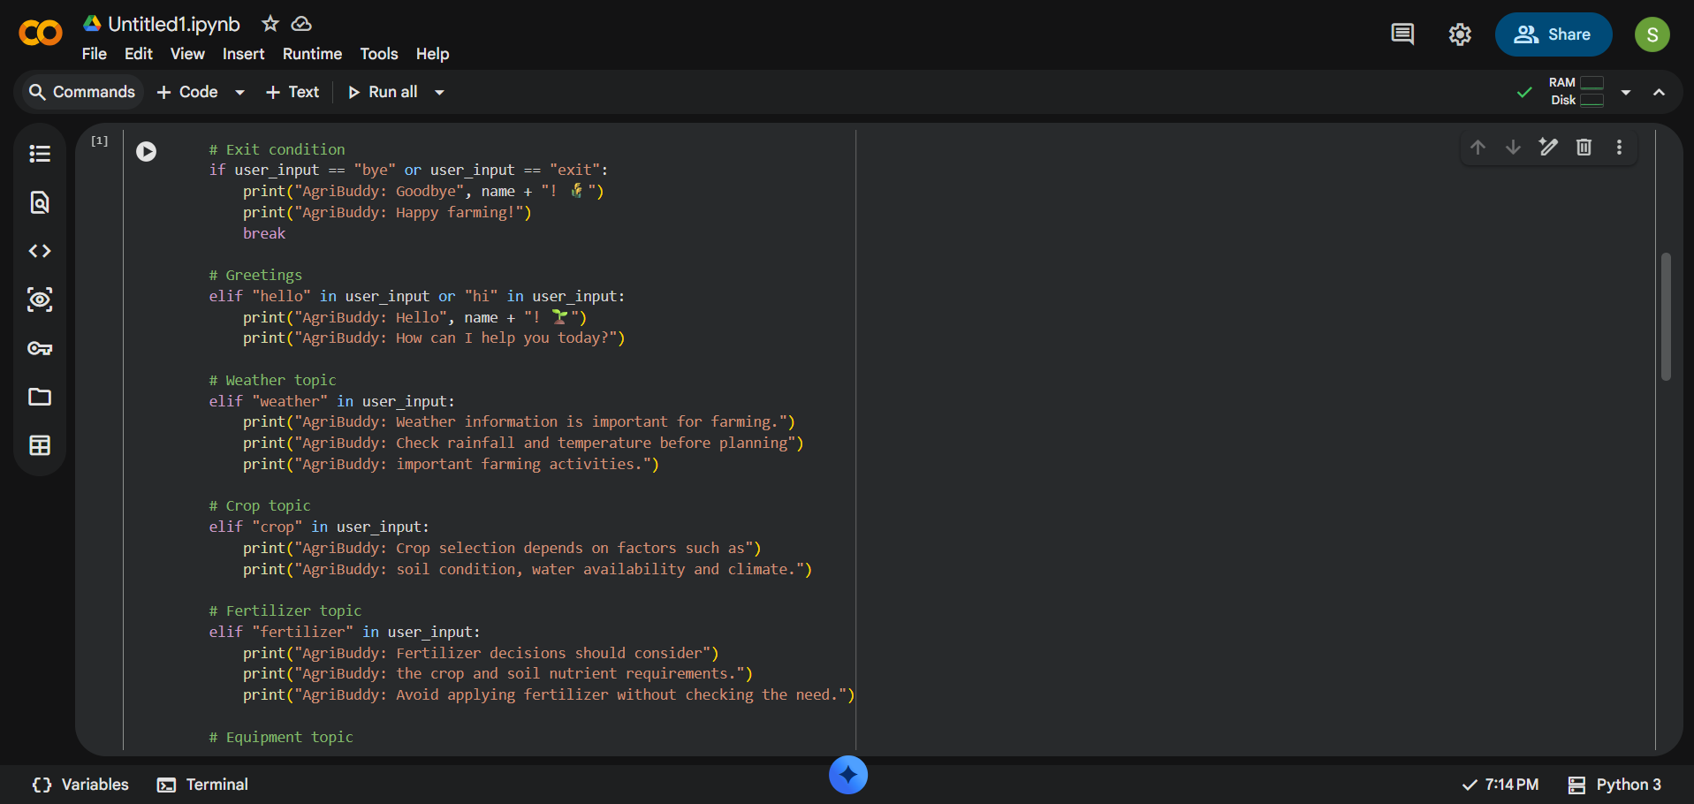
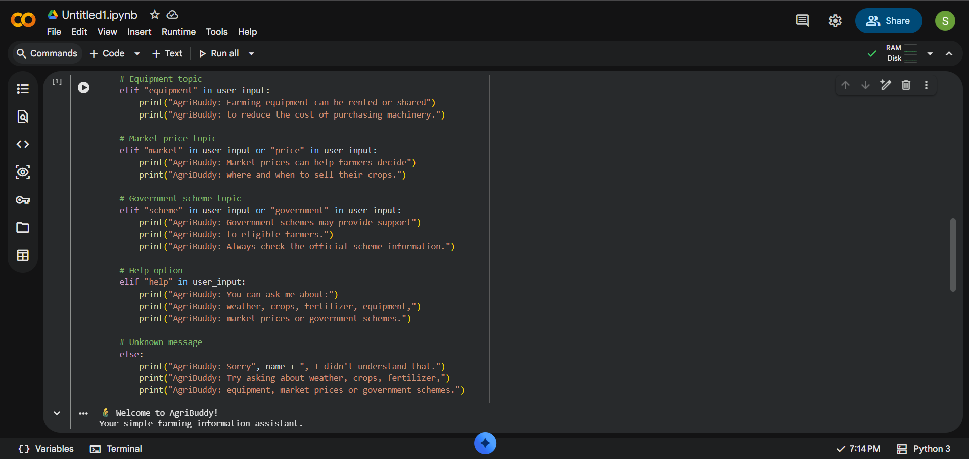OUTPUT:
🌾 Welcome to AgriBuddy!
Your simple farming information assistant.
What is your name? Sindhu

Hello Sindhu! 👋
I can help you with:
1. Weather
2. Crops
3. Fertilizer
4. Equipment
5. Market prices
6. Government schemes
Type 'bye' or 'exit' to leave.

You: weather
AgriBuddy: Weather information is important for farming.
AgriBuddy: Check rainfall and temperature before planning
AgriBuddy: important farming activities.
You: crop
AgriBuddy: Crop selection depends on factors such as
AgriBuddy: soil condition, water availability and climate.
You: fertilizer
AgriBuddy: Fertilizer decisions should consider
AgriBuddy: the crop and soil nutrient requirements.
AgriBuddy: Avoid applying fertilizer without checking the need.
You: equipment
AgriBuddy: Farming equipment can be rented or shared
AgriBuddy: to reduce the cost of purchasing machinery.
You: market prices
AgriBuddy: Market prices can help farmers decide
AgriBuddy: where and when to sell their crops.
You: bye
AgriBuddy: Goodbye Sindhu! 🌾
AgriBuddy: Happy farming!

